Unit 3
Software Development Life Cycle
The software development lifecycle (SDLC) is a structured and iterative methodology used by development teams to build, deliver and maintain high-quality and cost-effective software systems. The SDLC aims to produce a high-quality software that meets or exceeds customer expectations, reaches completion within times and cost estimates.
The SDLC helps development teams create software that meets stakeholder needs, project requirements and customer expectations. There are various SDLC models, such as the waterfall model, agile model, etc.

3.1 Importance and Need of SDLC
The Software Development Life Cycle (SDLC) is important because it provides a structured and systematic process for developing high-quality software. Here are the main reasons why it matters:
- Clarity of Requirements – SDLC ensures that the client’s needs are clearly gathered and understood before development begins, reducing confusion later.
- Better Planning & Organization – By breaking the process into phases, teams can manage time, cost, and resources effectively.
- Improved Quality – Regular reviews and testing at each stage help detect and fix issues early, leading to reliable and high-quality software.
- Cost & Time Efficiency – Early identification of problems saves money and effort compared to fixing them after deployment.
- Risk Management – Structured stages allow teams to foresee potential risks and handle them before they become big issues.
- Customer Satisfaction – Since the end product aligns with client requirements and is well-tested, it increases user trust and satisfaction.
- Maintainability & Scalability – SDLC ensures proper documentation and structured design, making the software easier to maintain, upgrade, or scale in the future.
- Efficient Resource Use – Helps in proper planning of time, cost, and manpower.
- Better Communication – Creates a common framework for clients, developers, and testers to coordinate effectively.

In short: SDLC is important because it gives a roadmap that helps software projects succeed—on time, within budget, and with good quality.
NOTE: Write same answers for both importance and needs of SDLC.
Phases of System Development Life Cycle (SDLC)
- Planning Phase
- Define the problem and objectives.
- Decide project scope, schedule, budget, and resources.
- Conduct feasibility study (technical, economic, operational).
- System Analysis Phase
- Gather and study requirements from users.
- Analyze existing system (if any).
- Prepare System Requirement Specification (SRS) document.
- System Design Phase
- Create a blueprint of the system.
- Design database, user interfaces, inputs/outputs, and architecture.
- Prepare detailed design for coding.
- Development (Coding) Phase
- Convert design into actual software using programming languages.
- Write clean, efficient, and secure code.
- Testing Phase
- Test the system for errors, bugs, and performance issues.
- Conduct unit testing, integration testing, system testing, and user acceptance testing (UAT).
- Implementation (Deployment) Phase
- Install the system in the real environment.
- Train users and provide manuals.
- Migrate data from old system (if any).
- Maintenance Phase
- Fix issues after deployment.
- Provide updates, patches, and enhancements.
- Ensure system works smoothly in the long run.

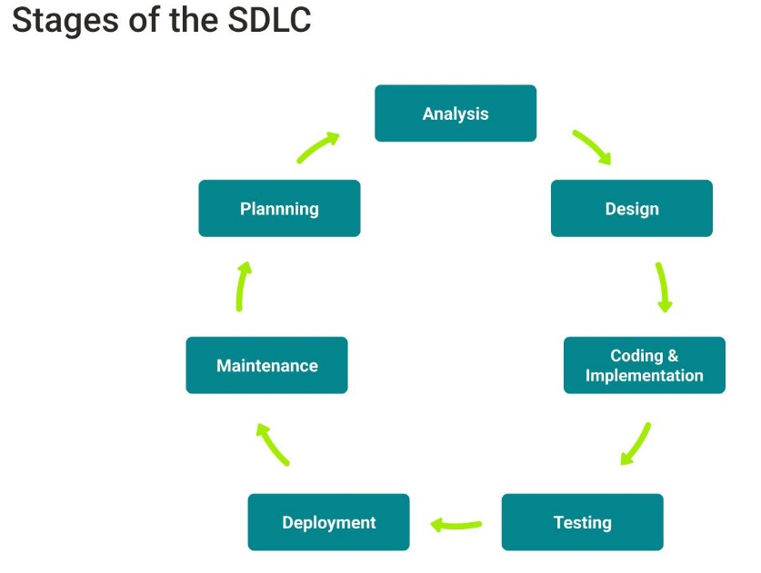

3.2 System Study
System study in SDLC is the process of investigating and analyzing the existing system and requirements to design a clear, feasible, and efficient new system.
It usually includes an analysis of the existing system and the design of the new system, including the development of system specifications which provide a basis for the selection of equipment.
It generally has two main parts:
- Preliminary Study (Initial Investigation)
- Understands the problem or need.
- Identifies the objectives of the proposed system.
- Checks feasibility (technical, economic, operational).
- Helps decide whether to proceed with the project.
- Detailed Study (System Analysis)
- Collects detailed information from users, documents, and existing systems.
- Defines user requirements clearly.
- Analyzes current problems and suggests improvements.
- Prepares a System Requirement Specification (SRS) document.

3.3 Feasibility Study
In the Software Development Life Cycle (SDLC), the feasibility study is an important early phase that determines whether a proposed software project is practical, achievable, and worth pursuing. As the name suggests, feasibility study is a study to reveal whether a project is feasible or not. It is conducted in order to objectively uncover the strengths and weaknesses of a proposed project or an existing business. It can help to identify and assess the opportunities and threats present in the natural environment, the resources required for the project, and the prospects for success.
It is conducted in order to find answers to the following questions:
- Does the company possess the required resources and technology?
- Will the company receive a sufficiently high return on its investment?

Types of Feasibility Study
1. Technical Feasibility
- Checks whether the technology, tools, and skills required for the project are available.
- Determines if the hardware and software can support the new system.
Example:
Can our existing servers and programming tools handle the new online payment system?
2. Economic Feasibility (Cost–Benefit Analysis)
- Evaluates whether the project is financially worthwhile.
- Compares expected costs (development, maintenance, training, etc.) with expected benefits (increased efficiency, reduced costs, higher revenue).
Example:
Will the new system save more money than it costs to build?
3. Operational Feasibility
- Assesses whether the system will function effectively in the organization’s environment.
- Checks if users will accept and use the new system.
Example:
Will employees be comfortable using the new software interface?
4. Legal Feasibility
- Ensures the project complies with all laws and regulations, such as data protection, copyright, or software licensing laws.
Example:
Does the software meet data privacy requirements?
5. Schedule Feasibility
- Determines whether the project can be completed within the required time frame.
- Considers deadlines, resource availability, and dependencies.
Example:
Can the system be developed and deployed before the next fiscal year starts?
6. Organizational (Behavioral) Feasibility
- Evaluates whether the project fits the organizational culture, structure, and objectives.
- Considers how the new system affects staff, workflows, and management practices.
Example:
Will introducing automation align with the company’s policies and employee roles?

3.4 System Requirements and Analysis
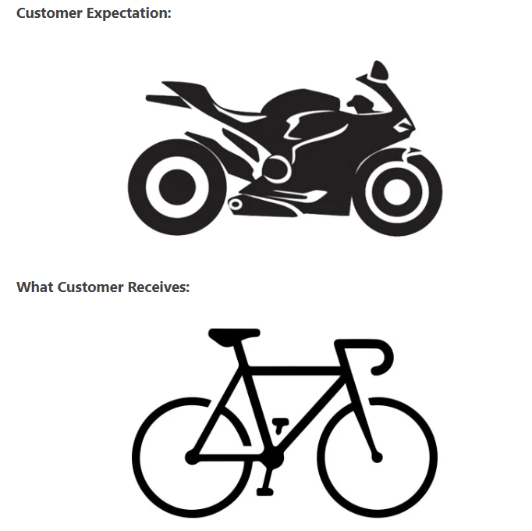
You can easily analyze from the above images that there is a mismatch in the end product to customer expectations. It can be due to many reasons like the incorrect implementation of customer requirements, faulty design, misunderstanding of customer requirements by programmers and quality team, etc.
A reasonable product delivery demands correct requirements gathering, the efficient examination of requirements gathered, and clear requirement documentation as a precondition. This entire process is known as Requirement.

System Requirement and Analysis is the second phase in the Software Development Life Cycle (SDLC). It comes after the Feasibility Study and before System Design. The main goal of this phase is to gather, analyze, and document all the requirements of the system that needs to be developed. It ensures developers clearly understand what the client wants and how the system should function.
Requirement Analysis begins with:
- Requirement Gathering, which is also known as Elicitation.
- Requirement Analysis: It is followed by Analyzing the collected requirements to understand the feasibility and correctness of converting the requirements into a possible product.
- Requirement Specification: Create a detailed document called the SRS (Software Requirement Specification).
It includes:
- Functional requirements – what the system should do
- Non-functional requirements – performance, reliability, security, usability, etc.
- Interfaces – how the system interacts with users or other systems
- Validation
- Confirm with stakeholders that the documented requirements correctly reflect their needs.
- Any missing or incorrect requirements are corrected before moving to design.

3.5 System Requirements Specification (SRS)
System Requirements Document is also known as System Requirements Specifications.
A System Requirements Specification (SRS) (also known as a Software Requirements Specification) is a document or set of documentation that describes the features and behavior of a system or software application. It comprises of various elements that attempt to characterize the functionality needed by the client to satisfy their users. In other words, the system requirements document (SRD) describes the system-level performance and functional requirements for a system.
Characteristics of good SRS
- Correctness: User review is used to provide the accuracy of requirements stated in the SRS. SRS is said to be perfect if it covers all the needs that are truly expected from the system.
- Completeness: The SRS is complete if all essential requirements, whether relating to functionality, performance, design, constraints, attributes, or external interfaces.
- Consistency
- Unambiguousness: SRS is unambiguous (clear) when every fixed requirement has only one interpretation.
- Modifiability: SRS should be made as modifiable as likely and should be capable of quickly obtain changes to the system to some extent. Modifications should be perfectly indexed and cross-referenced.
- Verifiability: SRS is correct when the specified requirements can be verified with a cost-effective system to check whether the final software meets those requirements. The requirements are verified with the help of reviews.
- Traceability: The SRS is traceable if the origin of each of the requirements is clear and if it facilitates the referencing of each condition in future development or enhancement documentation.
- Testability: An SRS should be written in such a method that it is simple to generate test cases and test plans from the report.
- Understandable by the customer: An end user may be an expert in his/her explicit domain but might not be trained in computer science. Hence, the purpose of formal notations and symbols should be avoided too as much extent as possible. The language should be kept simple and clear.

3.6 System Design
System Design is the process of designing the architecture, components, and interfaces for a system so that it meets the end-user requirements. It is the phase where the SRS document is converted into a format that can be implemented and decides how the system will operate.
In this phase, the complex activity of system development is divided into several smaller sub-activities, which coordinate with each other to achieve the main objective of system development. This phase provides the prototype of final product.

Inputs to System Design
System design takes the following inputs −
- Statement of work
- Requirement determination plan
- Current situation analysis
- Proposed system requirements including a conceptual data model, modified DFDs, and Metadata (data about data).

Outputs for System Design
System design gives the following outputs −
- Infrastructure and organizational changes for the proposed system.
- A data schema, often a relational schema.
- Metadata to define the tables/files and columns/data-items.
- A function hierarchy diagram or web page map that graphically describes the program structure.
- Actual or pseudocode for each module in the program.
- A prototype for the proposed system.
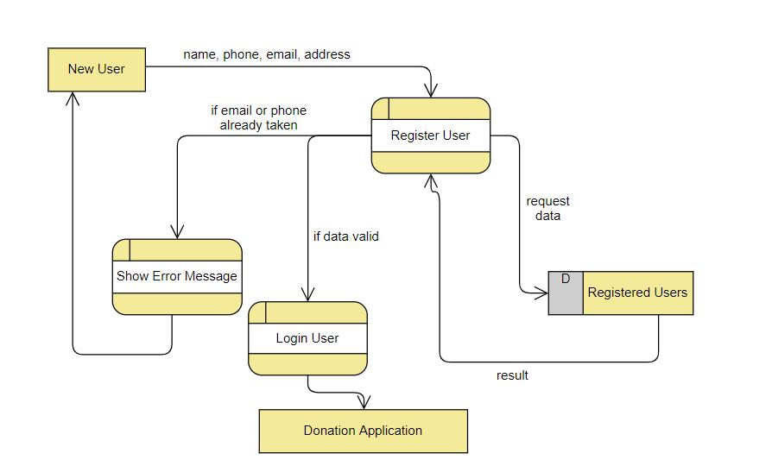

3.7 System Development
In this phase of SDLC, the actual development begins, and the programming is built. The implementation of design begins concerning writing code. Developers have to follow the coding guidelines described by their management and programming tools like compilers, interpreters, debuggers, etc. are used to develop and implement the code.

3.8 System Testing
After the code is generated, it is tested against the requirements to make sure that the products are solving the needs addressed and gathered during the requirements stage.
During this stage, unit testing, integration testing, system testing, acceptance testing is done.

3.9 System Implementation
System implementation is the process of making the new system operational and available to a prepare set of users (the deployment), and positioning on -going support and maintenance of the system.
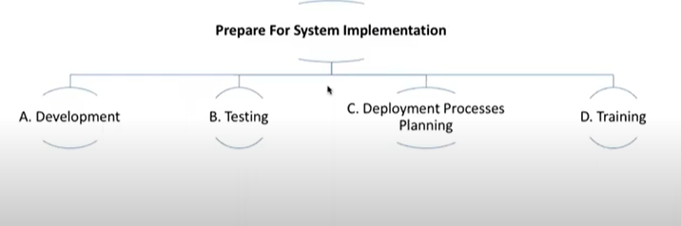

This phase is initiated after the system has been tested and accepted by the user. In this phase, the system is installed to support the intended business functions. System performance is compared to performance objectives established during the planning phase. Implementation includes user notification, user training, installation of hardware, installation of software onto production computers, and integration of the system into daily work processes. This phase continues until the system is operating in production in accordance with the defined user requirements.

3.10 System Maintenance
Once when the client starts using the developed systems, then the real issues come up and requirements to be solved from time to time. This procedure where the care is taken for the developed product is known as maintenance. It stands for all the modifications and updations done after the delivery of software product. There are number of reasons, why modifications are required, some of them are briefly mentioned below:
- Market Conditions - Policies, which changes over the time, such as taxation and newly introduced constraints like, how to maintain bookkeeping, may trigger need for modification.
- Client Requirements - Over the time, customer may ask for new features or functions in the software.
- Host Modifications - If any of the hardware and/or platform (such as operating system) of the target host changes, software changes are needed to keep adaptability.
- Organization Changes - If there is any business level change at client end, such as reduction of organization strength, acquiring another company, organization venturing into new business, need to modify in the original software may arise.

